Thoreau Leave No Trace Trail Participant Questionnaire
To earn the Thoreau Leave No Trace Trail medal and/or patch, you must meet the following requirements:
• Hike the entire trail
• Wear Class A or Class B uniform while hiking the trail
• Complete a questionnaire below
Questions: www.concordscouthouse.org or David Owen david.owen@concordscouthouse.org
What does Thoreau’s gravestone say on it?
Where is Thoreau’s Desk today?
What Thoreau quote is engraved on the threshold of the entrance to Brister’s Hill on the Emerson-Thoreau Amble?
What were the approximate dimensions of Thoreau’s Cabin at Walden?
Does the window Thoreau was born under face North, East, South or West?
What was the effect of Thoreau not following Leave No Trace and Fire'n Chit principles near Fairhaven Bay?
What furniture did Thoreau keep in his cabin?
What did Thoreau mean when he said, “Alas! how little does the memory of these human inhabitants enhance the beauty of the landscape!”
What year was Henry David Thoreau born?

Participant Name:
Date Trail Hiked:
Participant Rank:
Participant Unit No.
Participant Home Address:

AWARDS ORDER FORM:

Upon the completion of hiking the Thoreau Leave No Trace Trail EVERYONE, (not just Boy Scouts) has the option of purchasing trail awards. Please attach completed copies of the TLNT questionnaires along with this page for your group's order.

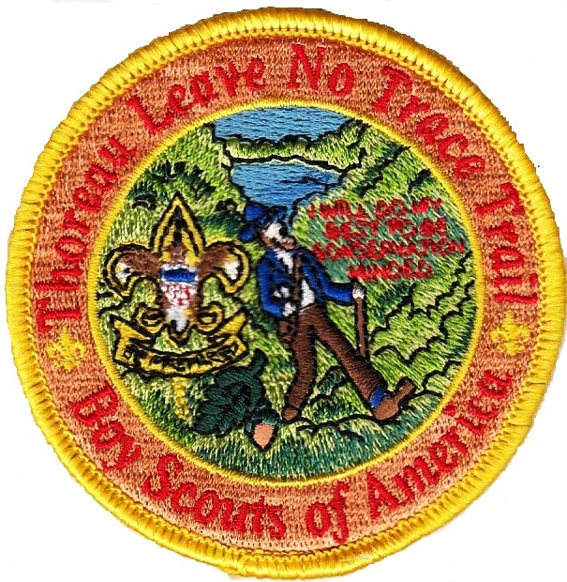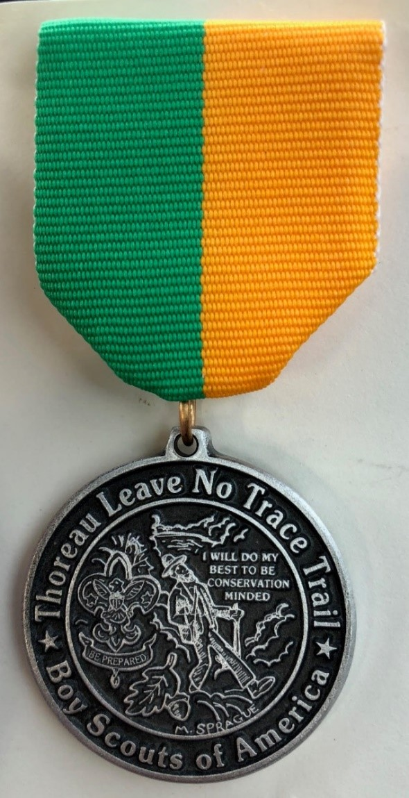

I wish to purchase _______ TLNT patches at a cost of ($6.00) each: $__________
I wish to purchase _______ TLNT medals at a cost of ($10.00) each: $__________
I wish to purchase _______ TLNT patch & medal sets at a cost of ($15.00) each: $__________

Subtotal $__________

Postage: $2.00 for 1-5 patches, $3.00 for 6-19 patches, $3.50 for 20 patches & up. $__________

Postage: $3.25 for 1-3 medals, $4.25 for 4-9 medals, $5.25 for 10 medals & up. $__________

Make checks payable to: Concord Scout House Total $____________
(Do not forget to attach a completed copies of the questionnaire!)

Mail Checks and Forms to: Ship orders to:
TLNT – Concord Scout House ______________________________
c/o David Owen
281 Lexington Road ______________________________
Concord, MA 01742
______________________________

Medals and patches are available to registered members of Scoutreach units at no cost, other than shipping.

The price of the medals and patches is nominally greater than the cost to fund the administration of the trail and the provision of medals and patches to Scoutreach unit members.

