Minutemen’s Pursuit Trail Questionnaire and Order Form
To earn the Minutemen Pursuit Trail medal and/or patch, you must meet the following requirements:
- Hike or cycle from Meriam’s Corner to Prospect Hill
- Wear Class A or Class B uniform while hiking the trail
- Complete a questionnaire to be provided the day of the hike
Questions: www.concordscouthouse.org or David Owen – david.owen@concordscouthouse.org
What is carved in the stone located in the stone wall at Merriam's corner?
What happened at the “Blood Angle” on the Battle Road?
What is the name of the last survivor of the Battle of Lexington whose house is located at 955 Massachusetts Avenue in Lexington?
What is carved in the stone located in the stone at the Foot of the Rocks?
What happened at the Jason Russell House?

What is “Uncle Sam’s” last name?
Who is Whittemore Park named after and what did he do?
What town was called “West Cambridge” in 1807? (Ask someone. Or research online.)
How many flags are on display at the Menotomy Grill?
Where and what date was the first American flag flown according to the mural visible from 63 Union Square in Somerville?
Why does the trail patch say “Concord to Charlestown,” but the trail only goes as far as Somerville? (Ask someone. Or research online.)

Participant Name:
Date Trail Hiked:
Participant Rank:
Participant Unit No.
Participant Home Address:

AWARDS ORDER FORM:

Upon the completion of hiking the Minutemen’s Pursuit Trail EVERYONE, (not just Boy Scouts) has the option of purchasing trail awards. Please attach completed copies of the MPT questionnaires along with this page for your group's order.

(The patch is 3". The medal is 2.5” and includes an Olympic-style ribbon to be worn around the neck.)
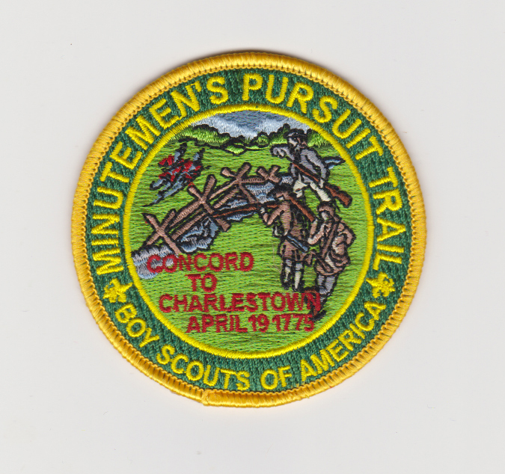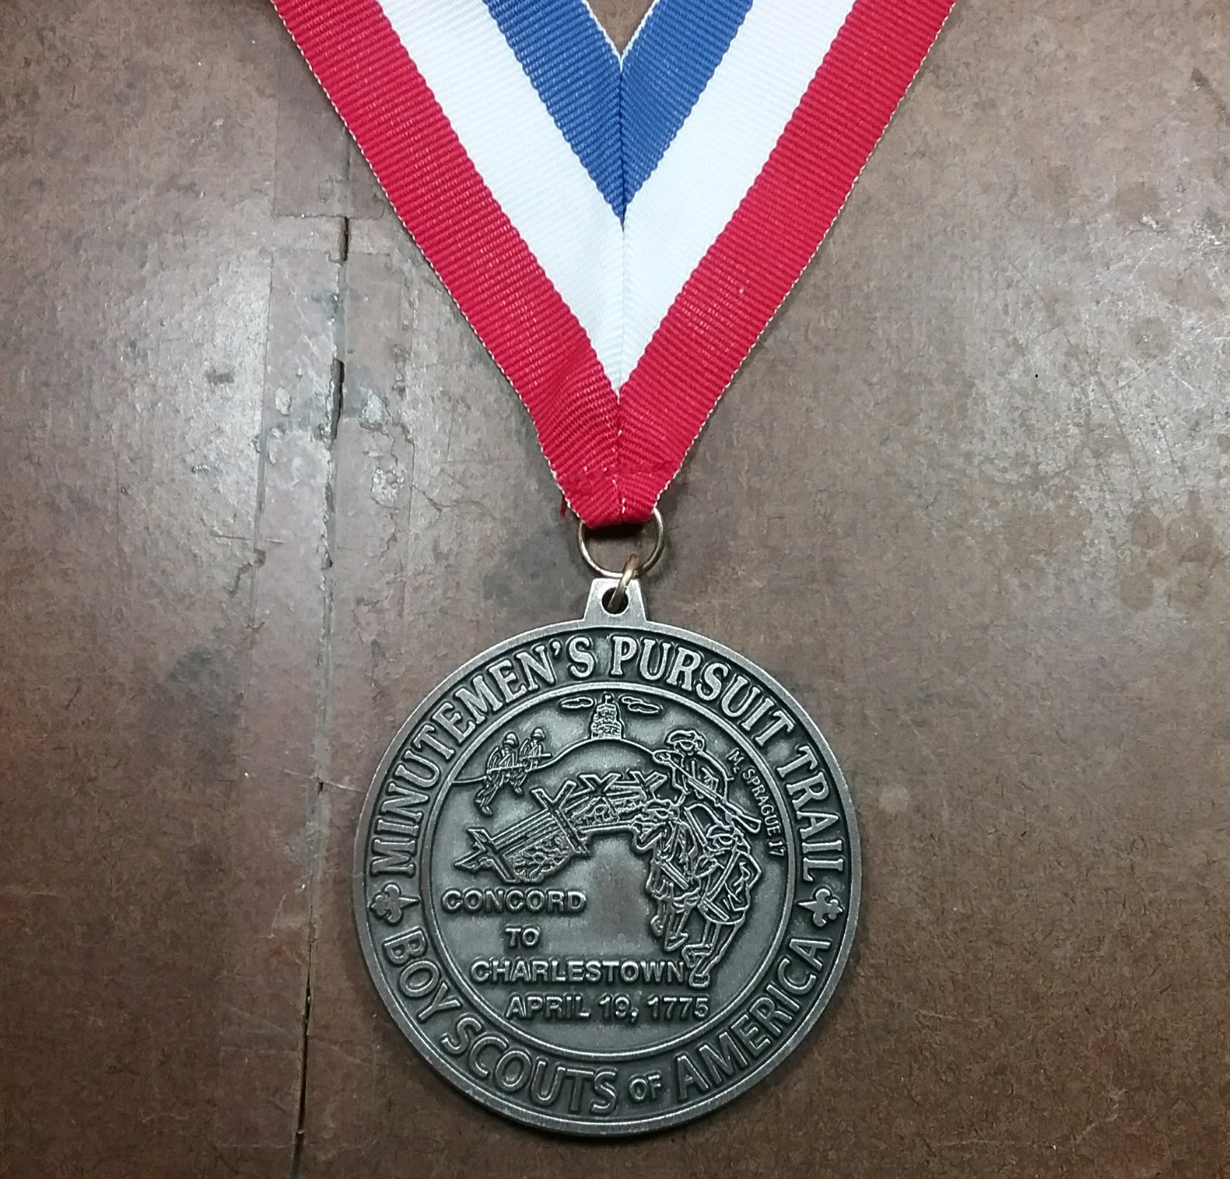

I wish to purchase _______ MPT patches at a cost of ($6.00) each: $__________
I wish to purchase _______ MPT medals at a cost of ($10.00) each: $__________
I wish to purchase _______ MPT patch & medal sets at a cost of ($15.00) each: $__________

Subtotal $__________

Postage: $2.00 for 1-5 patches, $3.00 for 6-19 patches, $3.50 for 20 patches & up. $__________

Postage: $3.25 for 1-3 medals, $4.25 for 4-9 medals, $5.25 for 10 medals & up. $__________

Make checks payable to: Concord Scout House Total $____________
(Do not forget to attach a completed copies of the questionnaire!)

Mail Checks and Forms to: Ship orders to:
MPT – Concord Scout House ______________________________
c/o David Owen
281 Lexington Road ______________________________
Concord, MA 01742
______________________________

Medals and patches are available to registered members of Scoutreach units at no cost, other than shipping.

The price of the medals and patches is nominally greater than the cost to fund the administration of the trail and the provision of medals and patches to Scoutreach unit members.

Minutemen’s Pursuit Trail
3 Legs (plus 2 Adjunct Legs)

Concord Adjunct Leg: 3.9 Miles
Concord Train Station – Concord Visitors’ Center – Old North Bridge – Wright Tavern – Concord Museum – Meriam’s Corner
https://goo.gl/maps/tr6BWvvCMjE2

Leg 1: 5.0 miles
Meriam’s Corner – Minuteman Visitor Center – Old Mass Ave. & Wood St.
https://goo.gl/maps/mhXeZL7punT2

Leg 2: 5.1 miles
Old Mass Ave. & Wood St. -- Lexington Common – Buckman Tavern – Monroe Tavern – Old Schwab Mill – Foot of the Rocks
https://goo.gl/maps/ZzWU2zjc6WU2

Leg 3: 6 miles
Foot of the Rocks – Jason Russell House – Menotomy Indian Hunter Sculpture – Uncle Sam Memorial -- Whittemore Park/Cyrus Dallin Museum – Menotomy Grill – Union Square – Prospect Hill
https://goo.gl/maps/d6wCArYMctR2

Boston Adjunct Leg: 2.4 miles
Prospect Hill – Gold Star Mother’s Park – Science Museum – North Station
https://goo.gl/maps/XzoFjxpMZL12

Bibliography

COBURN, FRANK WARREN
THE BATTLE OF APRIL 19, 1775, IN LEXINGTON, CONCORD, LINCOLN, ARLINGTON, CAMBRIDGE, SOMERVILLE and CHARLESTOWN, MASSACHUSETTS.
LEXINGTON, MASS., U. S. A., PUBLISHED BY THE AUTHOR, 1912.
http://thefederalistpapers.org/wp-content/uploads/2013/04/Battle-of-Lexington.pdf

Alternately, you may use a wheelchair, although an all-terrain wheelchair is recommended for the initial, Minute Man National Park, portion of the trail.

